============================================================
All problems are: ‘White to play and win’
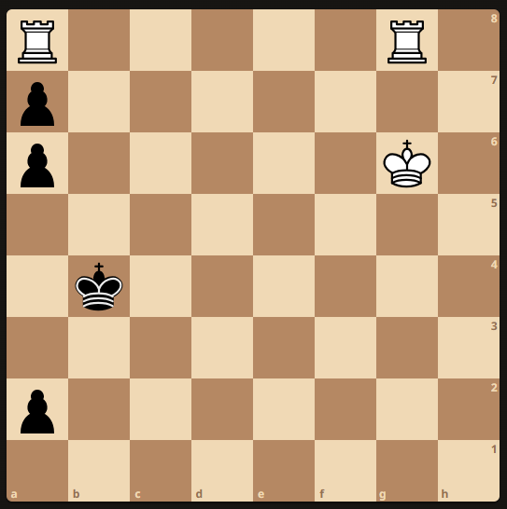
1.

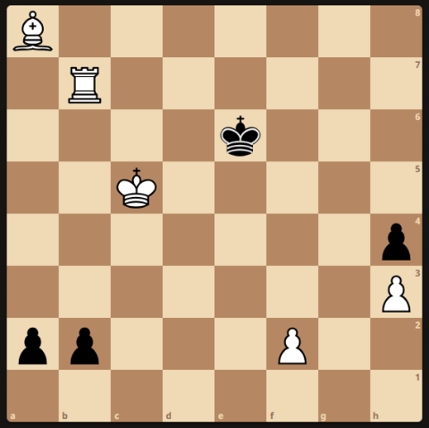
2.

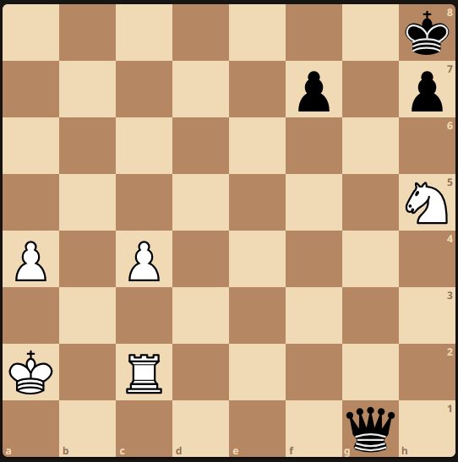
3.

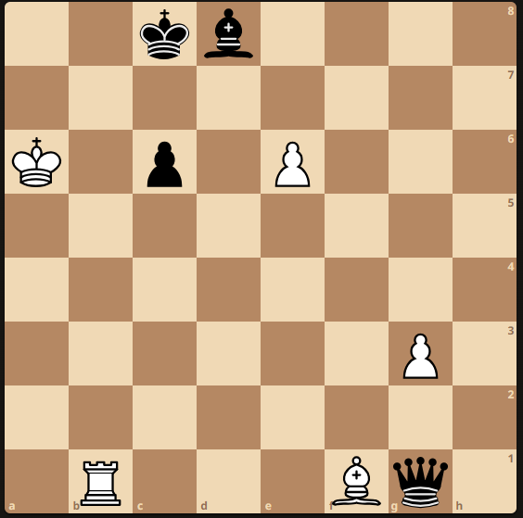
4.

U18 Section Solutions
1. Sourced from ‘Chess Vibes’.
1. Rgb8+
If 1. ... Kc3 2. Rc8+ Kd2 3. Rd8+ Ke2 4. Re8+ Kf2 5. Re1!!
If 1. ... Kc3 2. Rc8+ Kb3 3. Rab8+ Ka3 4. Rc6
If 1. ... Ka3 or Ka4 or Ka5 2. Rxa7

2. Sourced from ‘Chessfever1’.
1. Rf7 (threat Bd5+ and f4 mate) Kxf7 2. Bd5+ Kf6 3. Bxa2 Ke5 4. Bb1 Kf4
5. Kd5 Kf3 6. Ke5 Kxf2 (If … Kg2 7. Bf5) 7. Kf4 1-O

3. Przepiorka 1920
1. Re2 Qg8 2. Ng7

4. Slepyan 1983
1. 1. e7 Qxg3 2. Rb8+ Qxb8 3. Bh3+ Kc7 4. e8 (N)#

